“BEST OUT OF E- WASTE”

“BEST OUT OF E- WASTE” activity was conducted for B.A./B.Com. On 11th March 2020 from 12.45 pm to 2.15 pm, and the Judge for the competition was Mr. Satish Gangavati from BCA Department.
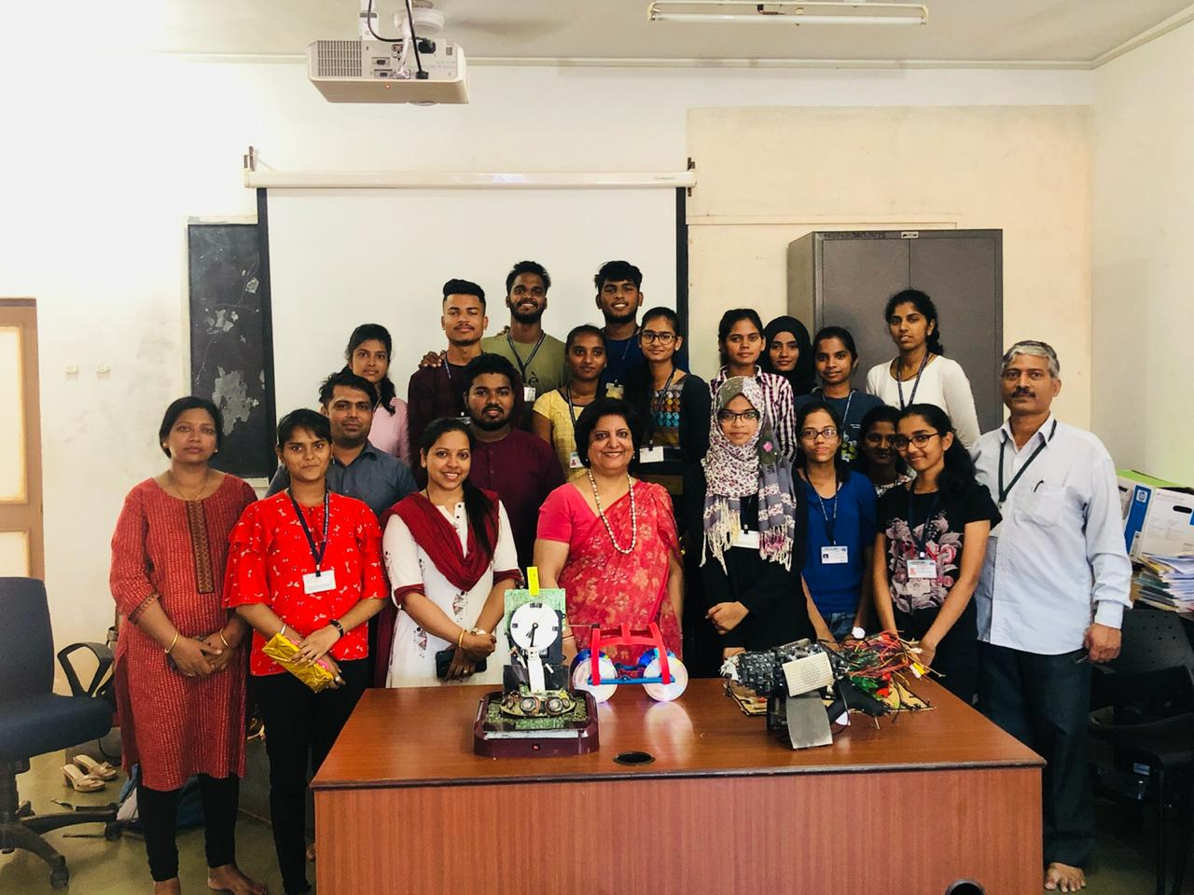
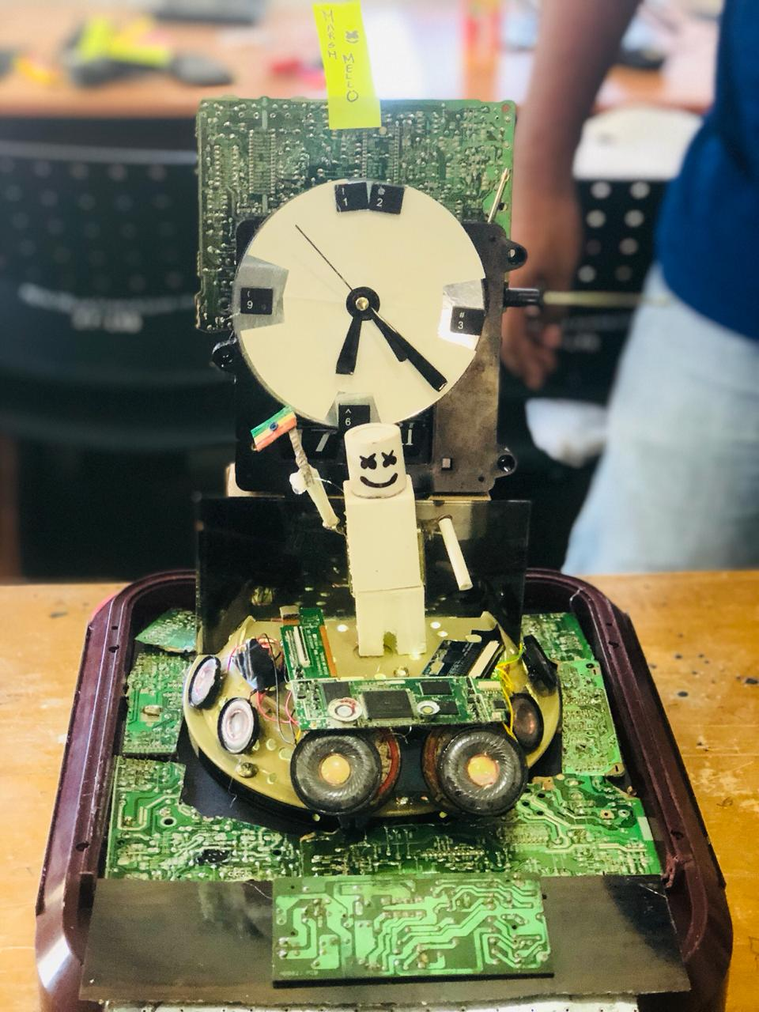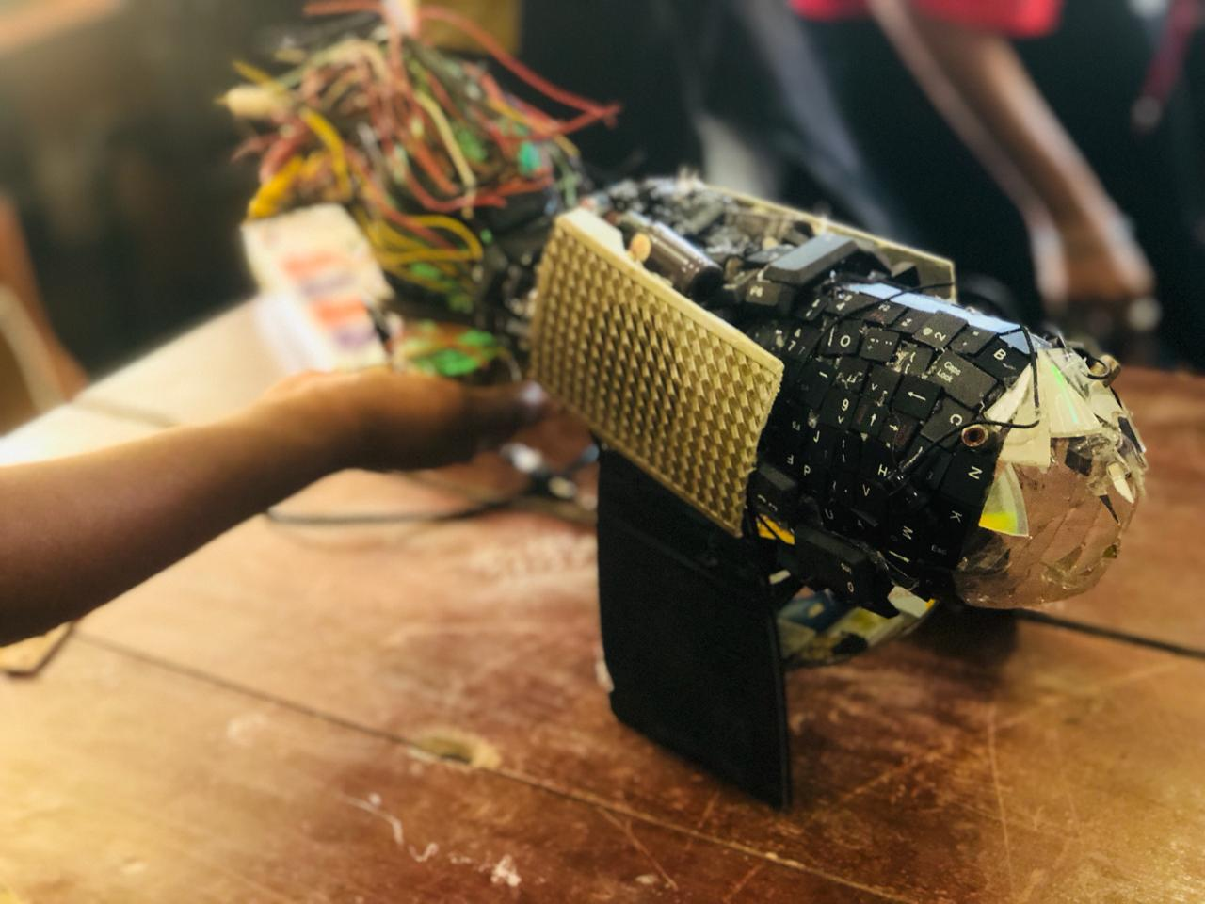

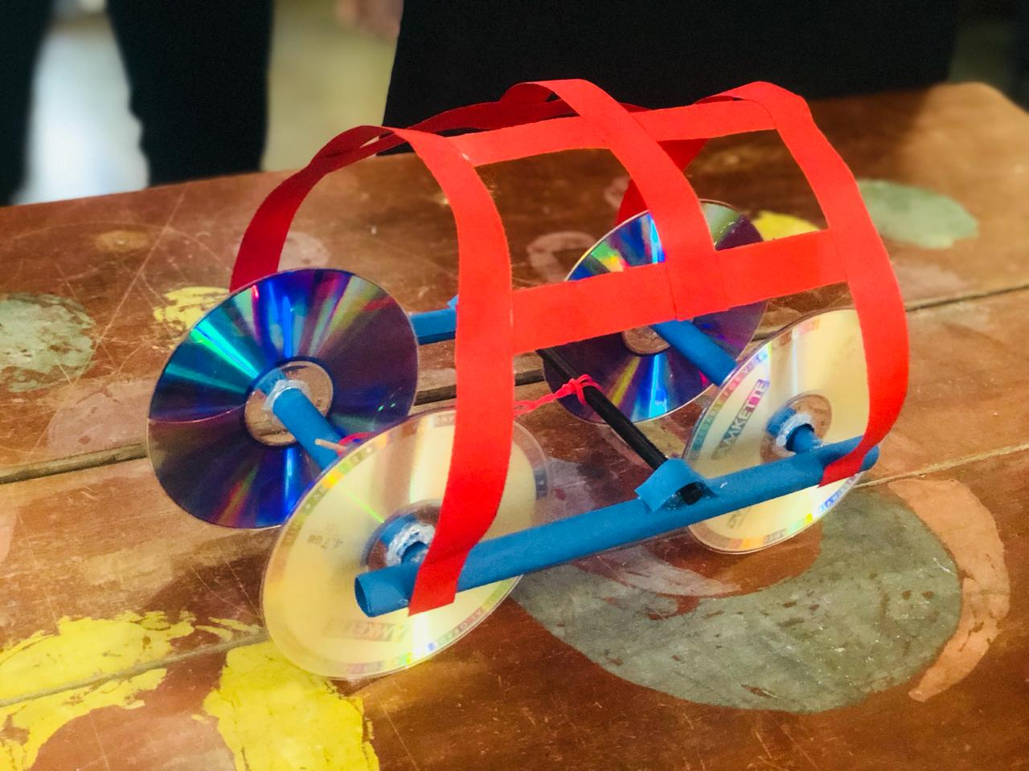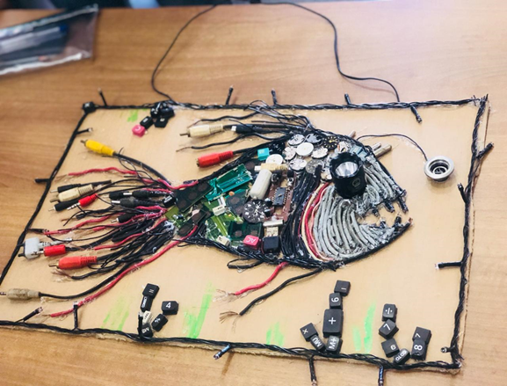

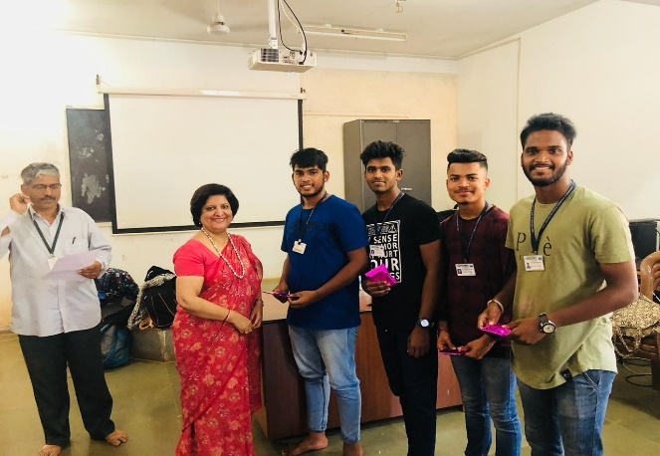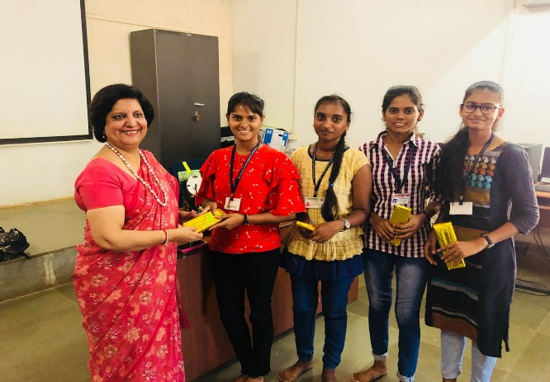

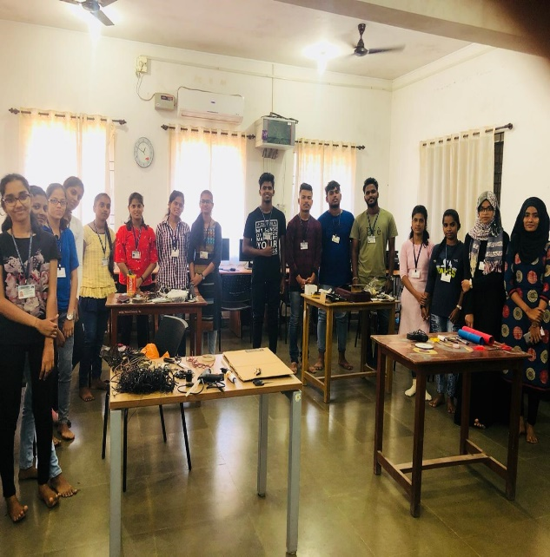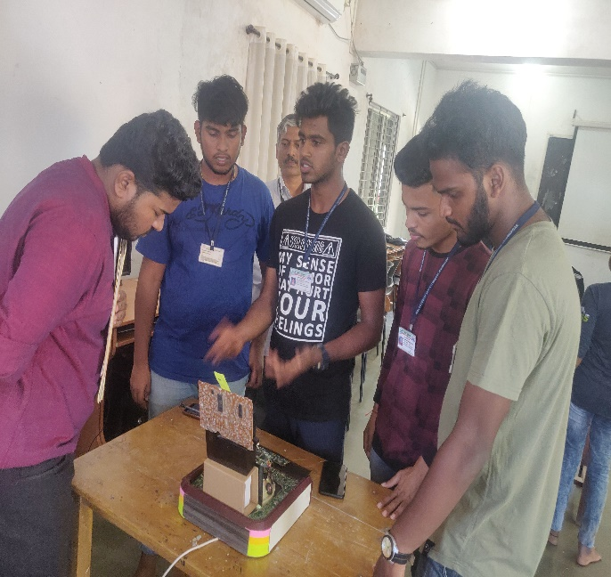

Date: 12/03/2020 (Shri. Sandeep M. Kadam)
Place : Zuarinagar Assoc. Prof. & HOD,
Dept. of Information Technology

